Predicting Loneliness in College Students During a Pandemic

UNC Chapel Hill

Olivia Nichols, Luyang Jia, Said Alhassan, Jessica Barta, Allene Xing

Luyang Jia: Writing and presenting the method section, designing the draft of Qualtric survey, distributing the survey, using R to do data cleaning and run regressions, presenting on data cleaning

Said Alhassan: Writing Part of Results (Figures) and Discussion (2nd paragraph) section. A few questions on Qualtrics, Presenting on data on Isolation (wrote that too). Also distributed the survey.

Olivia Nichols: Writing and presenting introduction section, distributing the survey, finding and citing references, writing parts of the results and discussion section on priming, presenting findings for priming

Allene Xing: Created the “Demographics” section of the Qualtrics Survey, worked on the results section, worked on the discussion section was responsible for explaining why physical activity was not significant in predicting loneliness and will be presenting these findings

Jessica Barta: Wrote APA-style discussion of results, created results table (calculated standardized regression coefficients), edited/critiqued introduction, wrote 3rd paragraph of discussion on living on campus and loneliness, made slides and presented findings for these variables

**Authors’ Note**

This paper was prepared in partial fulfilment of the requirements for PSYC 533H. We have no conflicts of interest to disclose.

Predicting Loneliness in College Students During a Pandemic

Since March, the COVID-19 pandemic has caused many changes in the lifestyles and living arrangements of UNC students. With classes being changed to online instruction and restrictions being placed on gatherings and entrance into buildings, the daily routines of many students differ greatly from a few months prior. Up until very recently, gyms and other athletic facilities were closed. Group fitness activities such as organized sports are limited in order to prevent the spread of COVID-19. What effect have these changes had on student health? Research by Woods et al. on the COVID-19 pandemic’s effects on physical health (2020) has shown that a lack of physical activity due to quarantining and social distancing can have prolonged negative effects on overall health.

Our areas of interest included loneliness, depression, exercise, staying inside, and social isolation. Specifically, we were interested in researching the correlation between physical activity and loneliness in UNC students during the COVID-19 pandemic. Study analyses focused on the relationship between physical activity and loneliness by Pels and Kleinert have shown that there is a direct negative association between the two (2016). And the study by Sundbald et al. shows that a low rate of physical activity can predict increased feelings of loneliness (2008).

We were also interested in the effects of priming: will priming students with COVID-19 related words affect how they rate their mental health? We used two separate survey groups that participants were randomly assigned to; one survey had the word COVID-19 and the other did not. We predicted that students who took the survey with the term COVID-19 in it would be more likely to respond that their mental health is poor compared to students who took the survey without the word COVID-19. Research done by Moss and Lawrence (1998) found that priming subjects with information about stress caused them to perceive that they were stressed more than individuals who did not receive priming. In a review of theories explaining how one’s beliefs about their environment shape their health processes, Clifton and Kim (2020) propose that negative beliefs about one’s situation in life can result in poorer mental health.

The outcome that we measured is the perceived mental health of UNC students, specifically their perceived loneliness. The rates of exercise of students were measured as a predictor. Another predictor we used was the priming effect. We hypothesized that rates of exercise would predict students’ perceived loneliness and the priming word “COVID-19” would have a negative effect on the perceived mental health.

**Methods**

**Participants**

We posted the link of Qualtrics survey in some study groups and recruited 95 UNC students. Students were randomly assigned to the control group or the experimental group by Qualtrics, depending on the existence of the priming word “COVID-19”.

**Design**

All participants were asked basic demographic questions like gender, age, race, school year, and two questions on their living situations such as living on campus or not. Then, there is a short version of the International Physical Activity Questionnaire to measure participants’ rates of exercise (Booth, 2000). It has questions like “During the last 7 days, on how many days did you do vigorous physical activities (e.g. heavy lifting, digging, aerobics, or fast bicycling)?” After that, participants were randomly assigned to the control group or the experimental group to measure their perceived loneliness. Participants in the control group completed the traditional UCLA loneliness survey with 20 questions (e.g. “I am unhappy doing so many things alone”) on a 4-point scale from “I often feel this way” to “I never feel this way” (Russell et al., 1978). Those in the experimental group completed an adjusted version of the UCLA loneliness survey with “COVID-19” mentioned in the questions (e.g. “I am unhappy doing so many things alone during the COVID-19 pandemic”. Participants from both groups had an attention check question in the loneliness survey. This question was keyed oppositely from all the other questions, and participants who answered this question in the former pattern failed the attention check.

**Data Cleaning**

Among the 95 responses we had, 65 were complete and valid. Before doing the analysis, we cleaned the data in several ways: 1) score physical activity and perceived loneliness 2) filter out outliers in physical activity and 3) identify and drop responses that failed the attention check in the loneliness scale.

There are 6 variables on physical activity, asking the frequency (days/week) and the duration (minutes/day) of vigorous activity, moderate activity, and walking. We used the scoring protocol ([www.ipaq.ki.se](http://www.ipaq.ki.se)) to convert these variables into a single index for physical activity (Patterson, 2010). Each activity is weighted by MET (the multiples of the resting metabolic rate) to represent the average energy required for that activity. Walking MET-minutes/week = 3.3 * walking minutes * walking days; Moderate MET-minutes/week = 4.0 * moderate-intensity activity minutes * moderate days; Vigorous MET-minutes/week = 8.0 * vigorous-intensity activity minutes * vigorous days. A general index for physical activity can be calculated by summing the above three items. After having a single variable for physical activity, we created a histogram to view the distribution and identified 3 outliers using the boxplot (see *Figures 1 & 2*).

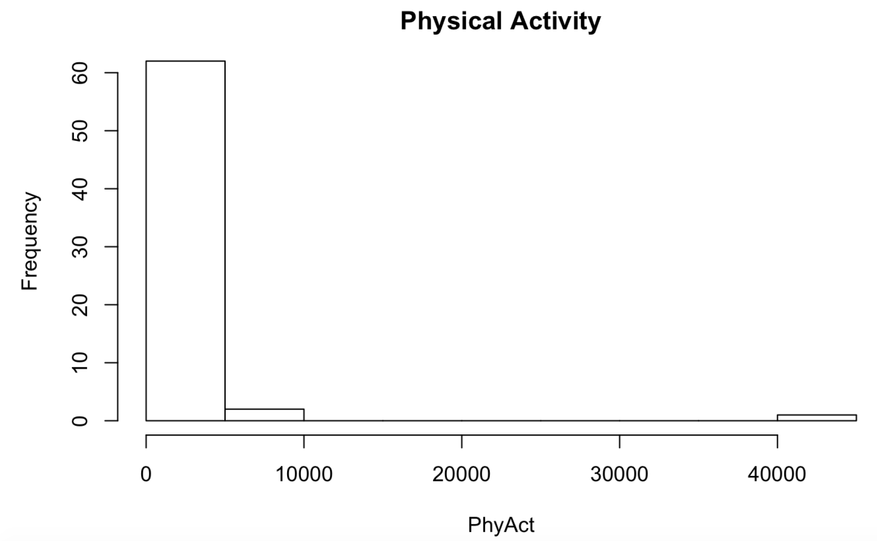

*Figure 1*. Histogram of physical activity.

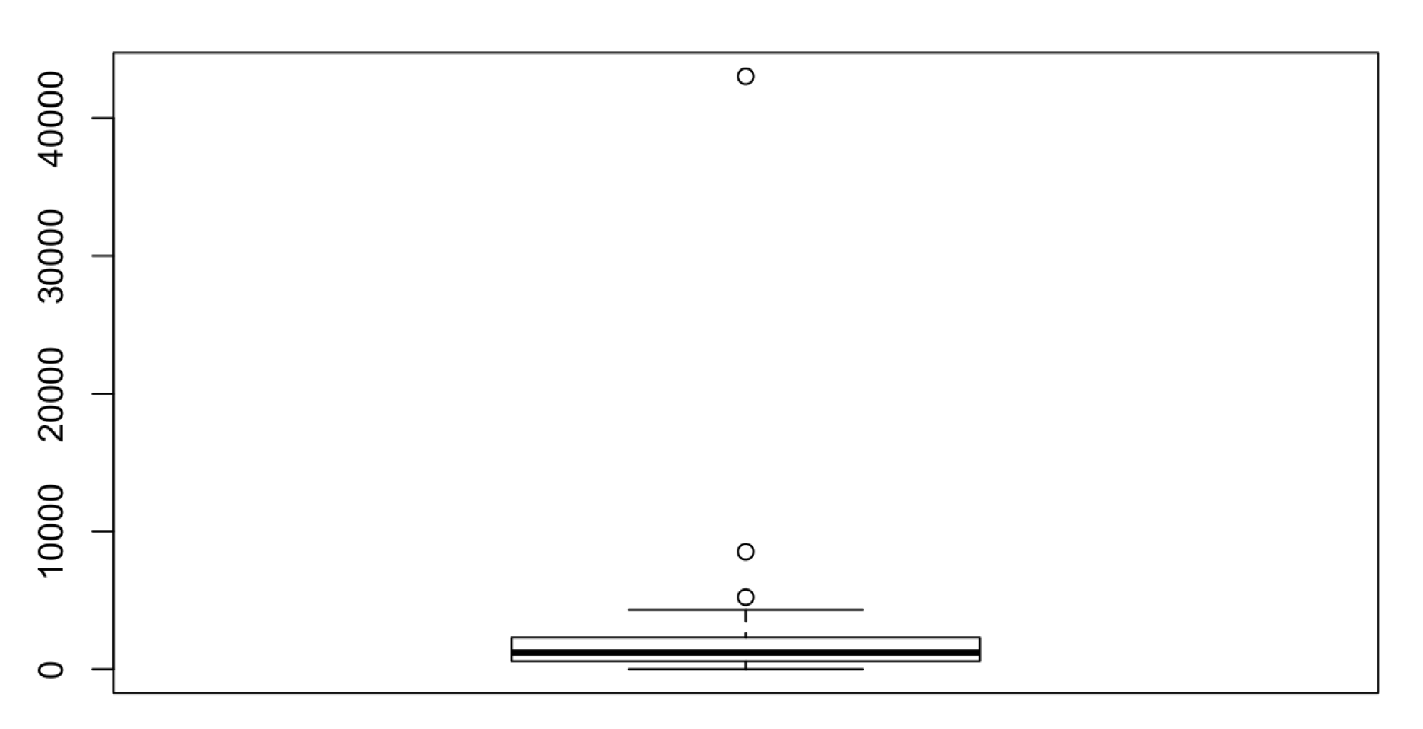

*Figure 2*. Boxplot of physical activity.

The UCLA loneliness scale has 20 questions and each of them was phrased in a negative way such as “ I am unhappy doing so many things alone”. In the original data set, “1” means “I often feel this way” and “4” means “I never feel this way”. So, a lower score represents higher perceived loneliness. An attention check question was added to this questionnaire with a positive phrasing: “I have enough support from my family/friends”. In this question, a higher score (4= “I never feel this way”) represents higher perceived loneliness. To ease the later analysis, we reverse coded the 20 questions in the loneliness scale. Then, a higher score means higher perceived loneliness. And we took the average of the converted scores to be a general index of perceived loneliness. Ideally, the score of the attention check question is positively correlated with the general index of perceived loneliness. If these two scores deviate a lot for a particular participant, we argued this participant failed the attention check since he/she followed the answering pattern of other questions and thus might not have read each question carefully. The scatterplot of the two scores shows a positive relationship (see *Figure 3*), but there are points in the top right corner and bottom right corner. To measure the deviation, we took the difference between the two scores and created a boxplot for the difference (see *Figure 4*). The 4 outliers shown in the boxplot are the responses that failed the attention check. After dropping these responses, we created a histogram for the general index of perceived loneliness (see *Figure 5*), and no outliers were identified. Overall, 7 responses were dropped and 58 responses were used in our data analysis.

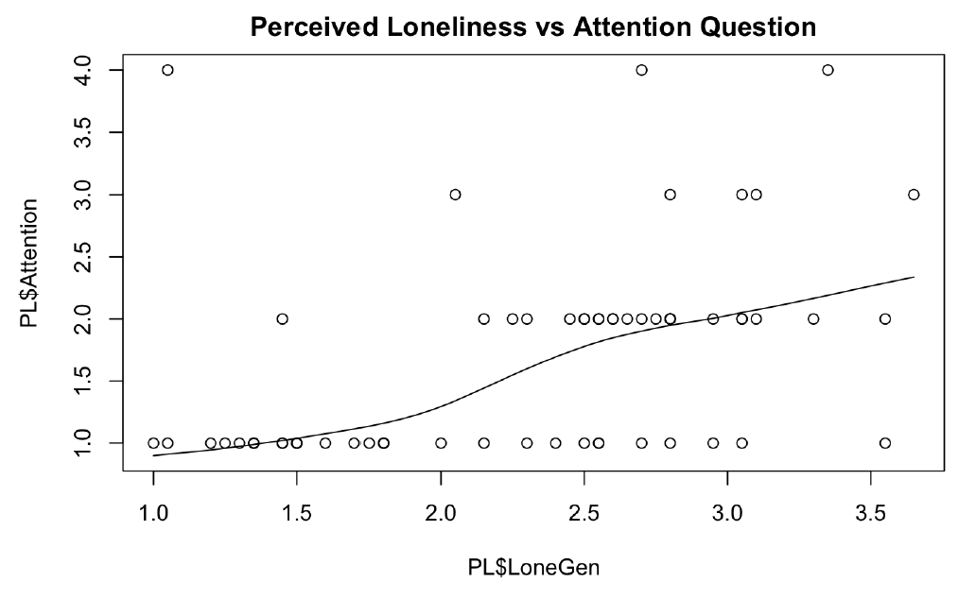

*Figure 3*. Scatterplot of perceived loneliness and the score of attention question.

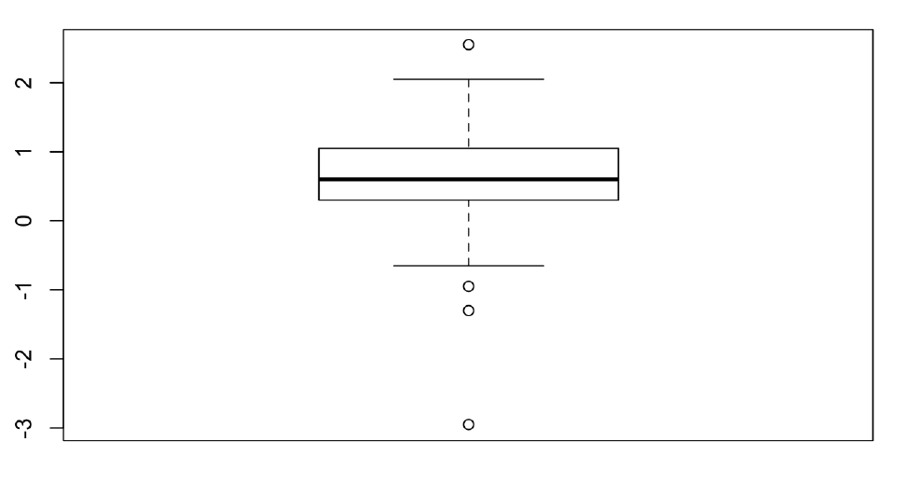

*Figure 4*. Differences between perceived loneliness and the score of attention question.

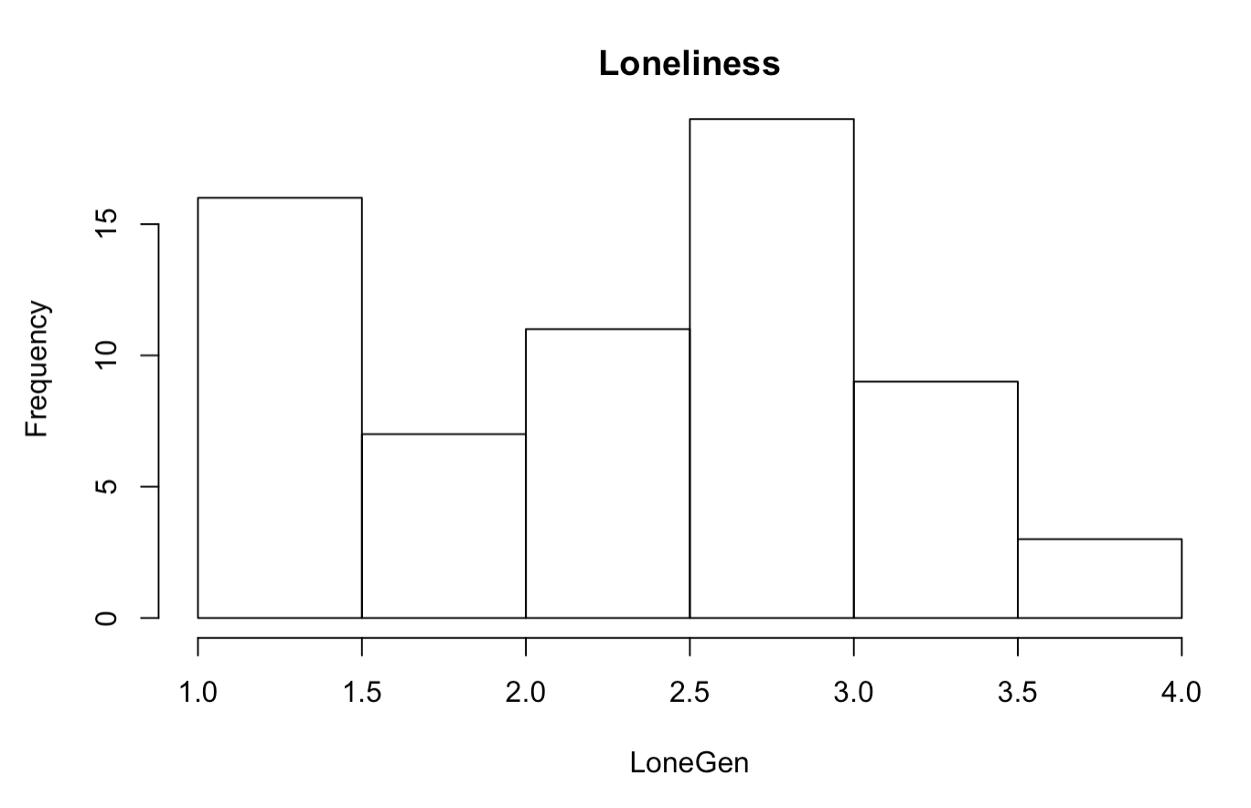

*Figure 5*. Histogram of perceived loneliness.

**Results**

Without considering interaction effects, we found a somewhat positive association between physical activity and perceived loneliness; in other words, Figure 6 shows that a student who exercises more may experience increased feelings of loneliness. We measured the effect of the interaction between priming and physical activity on the perceived loneliness of students. As shown in Figure 7, there is a significant difference in the slopes between the reported loneliness of groups who took the survey with “COVID-19” mentioned and that of groups who took the survey without it mentioned. Figure 8 shows the distributions of reported loneliness of both groups. On average, the group that was primed with “COVID-19” had higher scores for perceived loneliness than the group that was not primed. Running a linear model, we found that priming does have a significant effect on perceived loneliness. This is evidenced by the statistically significant p-value of 0.0229.

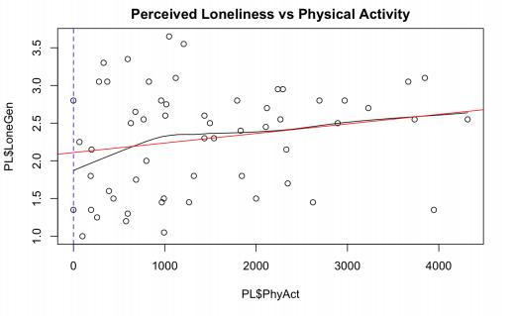

*Figure 6.* The relationship between physical activity and loneliness

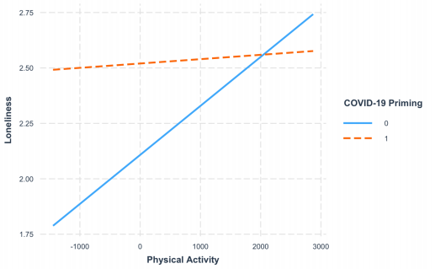

*Figure 7*. Plot of loneliness vs. physical activity with separate lines for participants who were primed with “COVID-19” and those who were not.

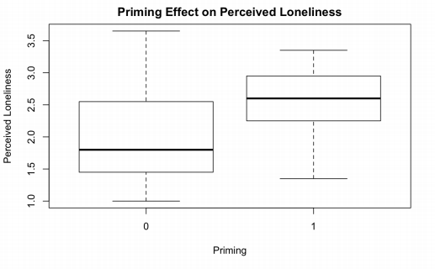

*Figure 8*. Boxplot of the distributions of perceived loneliness for the priming group and the non-priming group.

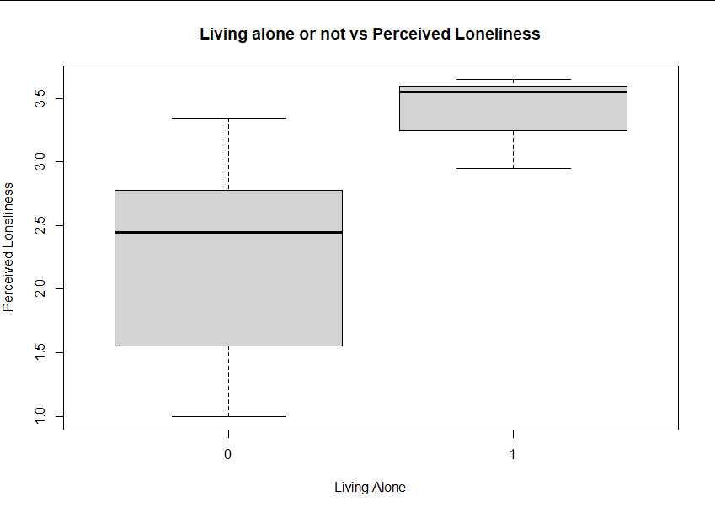

*Figure 9*. Boxplot of the distributions of perceived loneliness for living alone and not living alone.

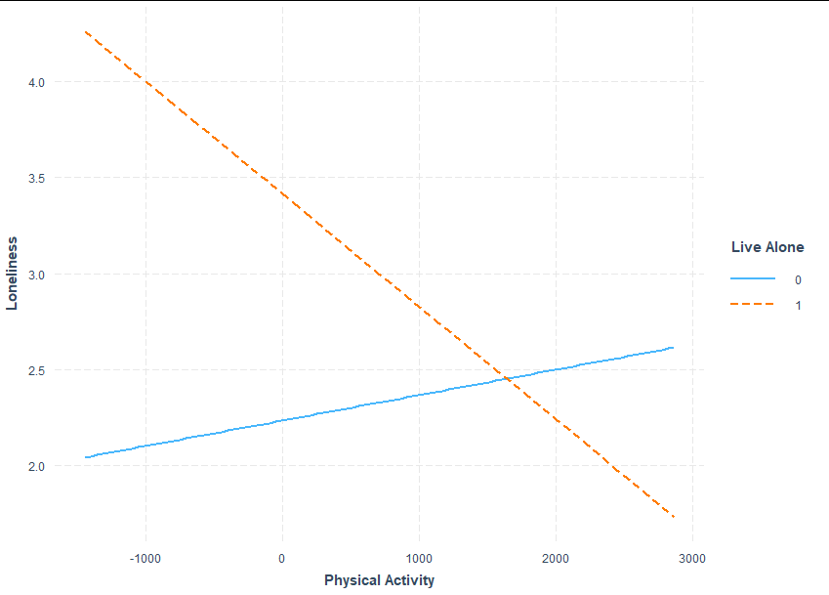

*Figure 10*. Plot of loneliness vs. physical activity with separate lines for participants who lived alone and those who did not live alone.

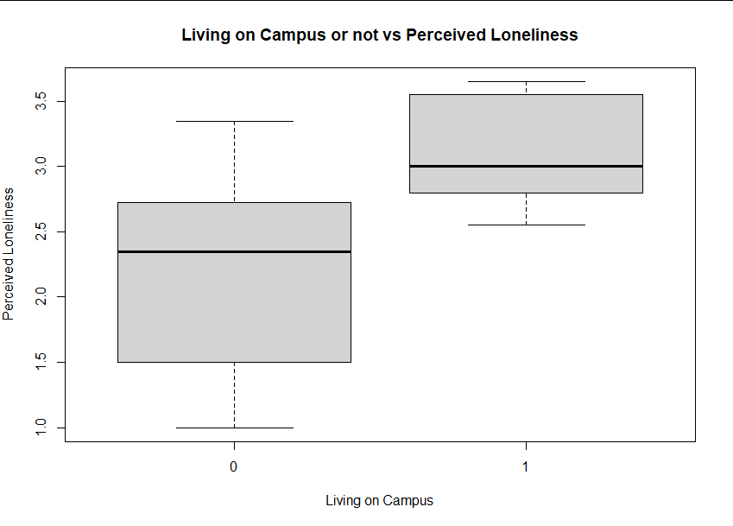

*Figure 11*. Boxplot of the distributions of perceived loneliness for living on campus and not living on campus.

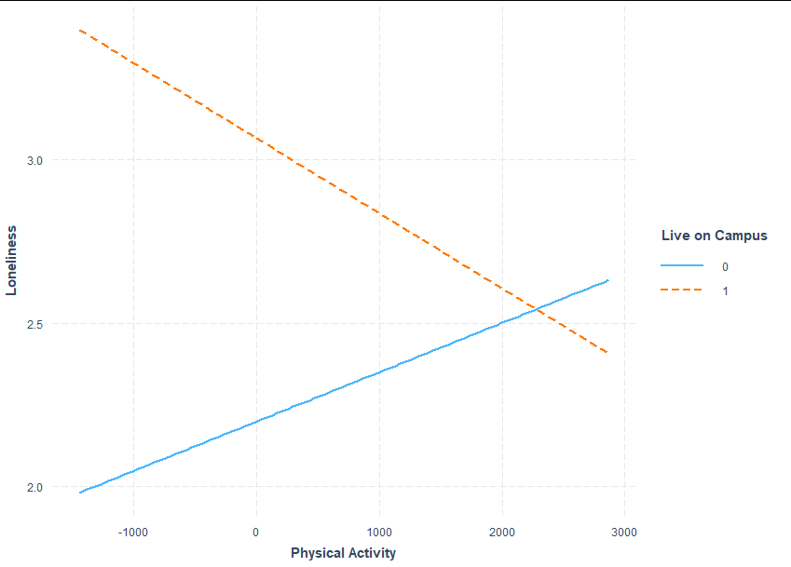

*Figure 12*. Plot of loneliness vs. physical activity with separate lines for participants who lived on campus and those who did not live on campus.

*Figure 13*. APA Chart

|  |  |  |  |
| --- | --- | --- | --- |
| Variable | B | SE B | β |
| PhysAct mean cent. | .0002211 | .0001307 | .0002211 |
| Priming | .4124* | .1761 | N/A |
| Live on campus | .8669* | .2765 | N/A |
| Live with family | 2.347 | .1622 | N/A |
| Live with roomate | -.2162 | .1949 | N/A |
| Live alone | 1.067* | .3838 | N/A |
| Live with partner | .3494 | 1.195 | N/A |
| Prefer not to say | .5526 | .6717 | N/A |

We conducted several regression analyses. First, we predicted loneliness scores based on mean-centered physical activity score, whether or not the participant was primed, and the interaction between these two variables. This model explained about 11% of the variance in loneliness, R^2=.1569, *F*(3, 54)=3.35, p>.03, Adj R^2=.1101. Next, we predicted loneliness scores using mean-centered physical activity, whether the participant lived on campus or not, and the interaction between these two variables. This model fit the data better and predicted 17% of the variance in loneliness, R^2=.2171, *F*(3, 54)=4.99, p=.004, Adj R^2=.1736. Next, we predicted loneliness using mean-centered physical activity, whether the participant lived with family, with a roommate, alone, with a partner, or whether they did not give this information, and using the interaction between these variables. This model did not predict loneliness better than the previous model and was only marginally significant, R^2=.2587, *F*(8, 49)=4.99, p=.04968, Adj R^2=.1376. Finally, we predicted loneliness using mean-centered physical activity, whether the participant lived alone, and the interaction between the two, R^2=.1916, *F*(3, 54)=4.265, p=.009, Adj R^2=.1467. This model predicted loneliness better than the first and third models, but did not predict loneliness as well as the second model. Based on these analyses, the model with physical activity and living on campus or not and their interaction best predicted loneliness. However, if the significance of each predictor (including interactions) is examined across the different models, the only significant predictors of loneliness are living on campus, *p*=.003, priming, *p*=.02, and living alone*,p*=.003. Overall, results supported our hypotheses that the presence of priming and living alone would significantly predict increased loneliness. At the same time, our other hypotheses that living on campus and exercising would significantly predict decreased loneliness, were not supported.

**Discussion**

By measuring the effects of priming on perceived loneliness, we have shown that the way students perceive their mental health is dependent on whether or not they consider the current circumstances of the pandemic. We can conclude that students believe that the pandemic has negatively impacted their mental health. One explanation for this is the negative portrayal of the pandemic in the media. Because of this negative portrayal, students may feel that everyone’s mental health has been negatively impacted by the pandemic and therefore theirs should too. Our reference literature found that if people view their situation in a pessimistic way, then their mental health will be negatively affected as a result (Clifton and Kim 2020). Our study’s results align with this conclusion.

We have also shown that students can feel very lonely in these dark times (pandemic) due to their isolation or living conditions. Many on campus students are limited in their social interactions due their housing predicament. Many other students live alone off campus. Given these factors, students have felt more lonely. Even exercise does not seem to help. When people who lived on campus or alone exercised they ended up feeling even more lonely. Perhaps due to social distancing, people tend to exercise alone and that enhances lonely thoughts since they aren’t around their usual workout friends or partners. Working out alone also gives people more time to think and on the flip side, more time to think about negative thougths.

Our findings show that remaining on campus predicts increased loneliness. This may be due to a combination of housing de-densification and being separated from friends without increases in social interaction from family. It may also be the case that living on campus may contribute to an increase in loneliness due to a larger gap between normal levels of social interaction on a campus and the currently experienced levels, a gap that is likely small to nonexistent within a family during the pandemic.

All in all, the results of our study seem to conflict with existing literature on the association between physical activity and loneliness. While previous literature suggests that increased physical activity can lead to decreased feelings of loneliness, we have found that physical activity does not seem to have a significant effect on predicting feelings of loneliness. This finding could be attributed to the fact that, in the presence of other interaction terms such as priming or living arrangements, physical activity may just not have as significant of an effect at predicting loneliness in the face of other factors.

References

Booth, M.L. (2000). *Assessment of Physical Activity: An International Perspective.* Research

Quarterly for Exercise and Sport, 71 (2): s114-20.

Clifton, J. D., & Kim, E. S. (2020, March 13). Healthy in a crummy world: Implications of primal world beliefs for health psychology. *Medical Hypotheses*. Retrieved October 14, 2020.

Moss, S., & Lawrence, K. (1998, December 04). The effects of priming on the self‐reporting of perceived stressors and strains. *Journal of Organizational Behavior*. Retrieved October 14, 2020, from <https://onlinelibrary.wiley.com/doi/10.1002/(SICI)1099-1379(199707)18:43.0.CO;2-5>

Pels, F., & Kleinert, J. (2016, June 07). Loneliness and physical activity: A systematic review. *International Review of Sport and Exercise Psychology*. Retrieved October 14, 2020, from <https://www.tandfonline.com/doi/abs/10.1080/1750984X.2016.1177849>

Russell, D , Peplau, L. A.. & Ferguson, M. L. (1978). Developing a measure of loneliness.

*Journal of Personality Assessment, 42,* 290-294.

Sundblad, G. B., Jansson, A., Saartok, T., Renström, P., & Engström, L. (2008). Self-rated pain

and perceived health in relation to stress and physical activity among school-students: A 3-year follow-up. *Pain,* *136*(3), 239-249. https://doi.org/10.1016/j.pain.2007.06.032

Woods, J., Hutchinson, N., Powers, S., Roberts, W., Gomez-Cabrera, M., Radak, Z., . . . Ji, L. (2020, May 30). The COVID-19 pandemic and physical activity. *Sports Medicine and Health Science*. Retrieved October 14, 2020, from <https://www.ncbi.nlm.nih.gov/pmc/articles/PMC7261095/>

Appendix

**UCLA LONELINESS SCALE**

# **Scale:**

INSTRUCTIONS: Indicate how often each of the statements below is descriptive of you.

|  |  |  |  |  |
| --- | --- | --- | --- | --- |
| O indicates “I often feel this way”  S indicates “I sometimes feel this way”  R indicates “I rarely feel this way”  N indicates “I never feel this way” |  | | | |
| 1. I am unhappy doing so many things alone | O | S | R | N |
| 2. I have nobody to talk to | O | S | R | N |
| 3. I cannot tolerate being so alone | O | S | R | N |
| 4. I lack companionship | O | S | R | N |
| 5. I feel as if nobody really understands me | O | S | R | N |
| 6. I find myself waiting for people to call or write | O | S | R | N |
| 7. There is no one I can turn to | O | S | R | N |
| 8. I am no longer close to anyone | O | S | R | N |
| 9. My interests and ideas are not shared by those around me | O | S | R | N |
| 10. I feel left out | O | S | R | N |
| 11. I feel completely alone | O | S | R | N |
| 12. I am unable to reach out and communicate with those around me | O | S | R | N |
| 13. My social relationships are superficial | O | S | R | N |
| 14. I feel starved for company | O | S | R | N |
| 15. No one really knows me well | O | S | R | N |
| 16. I feel isolated from others | O | S | R | N |
| 17. I am unhappy being so withdrawn | O | S | R | N |
| 18. It is difficult for me to make friends | O | S | R | N |
| 19. I feel shut out and excluded by others | O | S | R | N |
| 20. People are around me but not with me | O | S | R | N |

**Scoring:**

Make all O’s =3, all S’s =2, all R’s =1, and all N’s =0. Keep scoring continuous.

**INTERNATIONAL PHYSICAL ACTIVITY QUESTIONNAIRE**

We are interested in finding out about the kinds of physical activities that people do as part of their everyday lives. The questions will ask you about the time you spent being physically active in the **last 7 days**. Please answer each question even if you do not consider yourself to be an active person. Please think about the activities you do at work, as part of your house and yard work, to get from place to place, and in your spare time for recreation, exercise or sport.

Think about all the **vigorous** activities that you did in the **last 7 days**. **Vigorous** physical activities refer to activities that take hard physical effort and make you breathe much harder than normal. Think *only* about those physical activities that you did for at least 10 minutes at a time.

1. During the **last 7 days**, on how many days did you do **vigorous** physical activities

like heavy lifting, digging, aerobics, or fast bicycling?

_____ **days per week**

◻ No vigorous physical activities ***Skip to question 3***

2. How much time did you usually spend doing **vigorous** physical activities on one of those days?

_____ **hours per day**

_____ **minutes per day**

◻ Don’t know/Not sure

Think about all the **moderate** activities that you did in the **last 7 days**. **Moderate** activities refer to activities that take moderate physical effort and make you breathe somewhat harder than normal. Think only about those physical activities that you did for at least 10 minutes at a time.

3. During the **last 7 days**, on how many days did you do **moderate** physical activities like carrying light loads, bicycling at a regular pace, or doubles tennis? Do not include walking.

_____ **days per week**

◻ No moderate physical activities ***Skip to question 5***

SHORT LAST 7 DAYS SELF-ADMINISTERED version of the IPAQ. Revised August 2002.

4. How much time did you usually spend doing **moderate** physical activities on one of those days?

_____ **hours per day**

_____ **minutes per day**

◻ Don’t know/Not sure

Think about the time you spent **walking** in the **last 7 days**. This includes at work and at home, walking to travel from place to place, and any other walking that you have done solely for recreation, sport, exercise, or leisure.

5. During the **last 7 days**, on how many days did you **walk** for at least 10 minutes at a time?

_____ **days per week**

◻ No walking ***Skip to question 7***

6. How much time did you usually spend **walking** on one of those days?

_____ **hours per day**

_____ **minutes per day**

◻ Don’t know/Not sure

The last question is about the time you spent **sitting** on weekdays during the **last 7 days**. Include time spent at work, at home, while doing course work and during leisure time. This may include time spent sitting at a desk, visiting friends, reading, or sitting or lying down to watch television.

7. During the **last 7 days**, how much time did you spend **sitting** on a **week day**?

_____ **hours per day**

_____ **minutes per day**

◻ Don’t know/Not sure

**This is the end of the questionnaire, thank you for participating.**